 Year 8 Science 2021

Cell Biology and Microscope Test

**Student Name: _______________________________________**

Teacher:- *(please circle)*

**Prasad**  **Matthews**   **Mathurine**  **Fernandez**  **Hart**  **Van der Vaart**

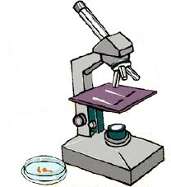

Please answer all questions in the spaces provided. You will have 40 minutes to complete the test.

Students will need to provide:

· Pencil/Pen

· Ruler

· Calculator

· Eraser

|  |  |  |  |
| --- | --- | --- | --- |
| Multiple-choice | Short answer | Microscope Practical | TOTAL |
| /10 | /34 | /8 | /52 |

**Part 1: Please circle the correct answer: (10 marks)**

1. Living things that are made from only one cell are called

a. multicellular

b. microcellular

c. unicellular

d. intracellular

1. The job of the mitochondria in cells is to

a. repair cell damage

b. store cell waste

c. control the cell’s activities

d. release energy

1. On the microscope, the objective lens is found on the

a. eyepiece

b. nosepiece

c. mouthpiece

d. chin piece

1. If the eyepiece lens has a magnification of x10, and the objective lens has a magnification of x4, the total magnification is what?

a. x2

b. x6

c. x14

d. x40

1. The word cyto means:
2. cell
3. dark
4. jelly
5. Small
6. Tiny structures that carry out cell functions are collectively called:
7. animalcules
8. organelles
9. tissues
10. ribosomes
11. Which technology was essential for the development of the cell theory?
12. telescopes
13. antiseptics
14. microwaves
15. microscopes
16. Human cheek cells are best described as
17. a cell wall
18. an organism
19. a plant cell
20. an animal cell

9. Which of the following statements is **false**

1. vacuoles store waste
2. plant cells have one large vacuole
3. all vacuoles have the exact same shape
4. animal cells have more than one vacuole

10. All cells extract energy from which process?

1. photosynthesis
2. cellular respiration
3. digesting food
4. sleeping

**Part 2: Short Answer (34 Marks)**

11. Correctly label the diagram below with the terms – **vacuole, nucleus, cell wall, cell membrane, cytoplasm** and **chloroplast.**

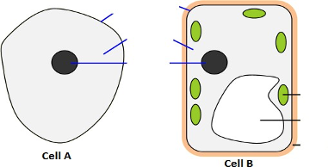

(6 marks)

12. From the diagram in question 2, which cell, A or B, is a plant cell? Give one reason for your answer

_____________________________________________________________________________________________________________________________________________________________________________________________________________________________________________________________________________________________________________________________________________________________________________

(2 marks)

13. Using the following structures complete the table below matching the correct structure

with the correct function:

**vacuole, nucleus, cell wall, cell membrane, cytoplasm** and **chloroplast.**

|  |  |
| --- | --- |
| **Structure** | **Function** |
|  | Controls what enters and leaves the cell |
|  | Traps light energy by photosynthesis |
|  | Gives support |
|  | Storage of water, food and wastes |
|  | Controls all cell activities |
|  | Jelly like substance containing all cell organelles |

(6 marks)

14. In **cellular respiration** glucose is chemically combined with oxygen producing:

Glucose + oxygen → ___________________ + ________________+ _______________

(3 marks)

15. Using the names provided in the table, label the microscope below with the correct names.

(8 marks)

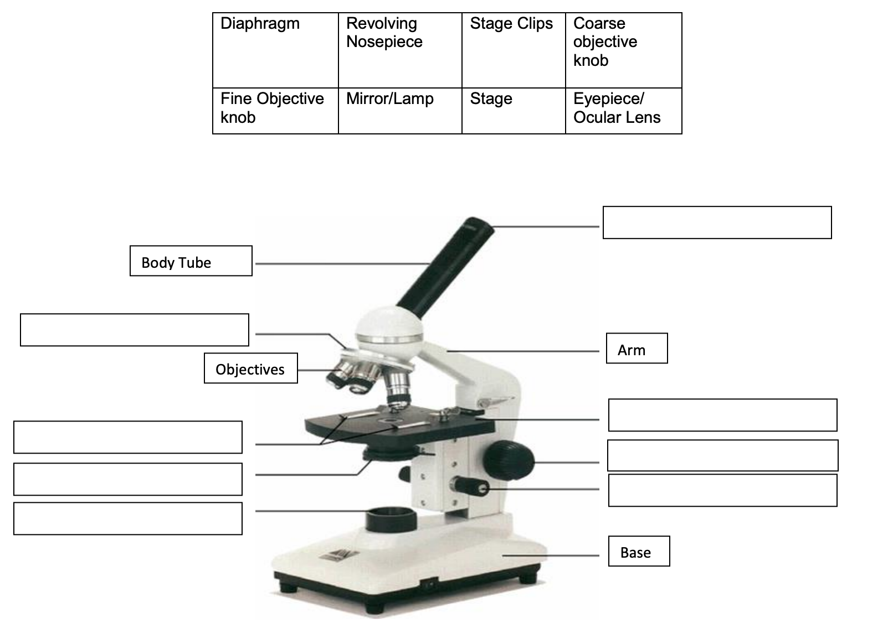

16. State the three principles of the cell theory. (3 Marks)

* **___________________________________________________________________________________________________________________________**
* **___________________________________________________________________________________________________________________________**
* **____________________________________________________________________________________________________________________________**

17. Explain at least one similarity and one difference between a mitochondrion & a chloroplast. (3 marks)

_____________________________________________________________________________________________________________________________________________________________________________________________________________________________________________________________________________________________________________________________________________________________________________

18. A cell membrane is ‘partially permeable’. This means that only certain substances are able to cross the membrane. List some substances that would need to get into the cell and some that would need to get out. (3 marks)

_____________________________________________________________________________________________________________________________________________________________________________________________________________________________________________________________________________________________________________________________________________________________________________

**Year 8 Biological Sciences 2020 **

**Practical: Microscope Skills Assessment**

Name: _____________________

**Microscope skills**

|  |  |  |
| --- | --- | --- |
| **Practical skill required** | **Marks achieved** | **Marks available** |
| Slide is in place and centred using stage clips or stage dials |  | 1 |
| Starts on the lowest objective lens possible (usually x4) |  | 1 |
| Use the coarse focus before the fine focus |  | 1 |
| Ability to focus properly |  | 1 |
| Names at least three parts |  | 2 |
| Handles microscope safely and correctly - question |  | 2 |

Total marks: / 8